**University of engineering & technology Peshawar**



**Object oriented programming-lab**

**Lab report no#01**

**Spring 2020**

**Submitted by: Ashfaq Ahmad**

**Section: B**

**Reg No: 19PWCSE1795**

**Semester: 3nd**

**“On my honor, as a student of University of Engineering and Technology Peshawar, I have neither given nor received unauthorized assistance on this academic work”**

Student signature: ____________________

**Submitted to:**

**Eng: Sumayyea salahuddin**

**Department Of Computer System Engineering**

**Task no 1:**

Create a class, Heater that contains a single integer field, temperature. Define a constructor that takes no parameters. The temperature field should be set to the value 15 in the constructor. Define the mutators: warmer and cooler, whose effect is to increase or decrease the value of the temperature by 5 respectively. Define an accessor method to return the value of temperature. Demonstrate the use of Heater class.

**Source code:**

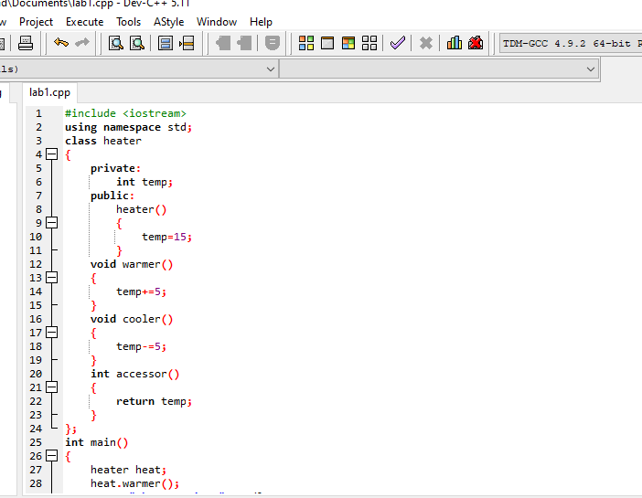

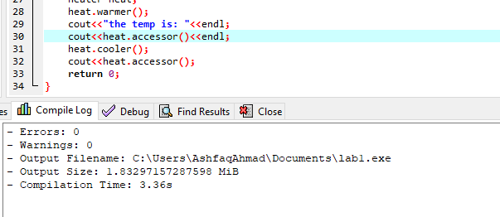

**Compilation:**

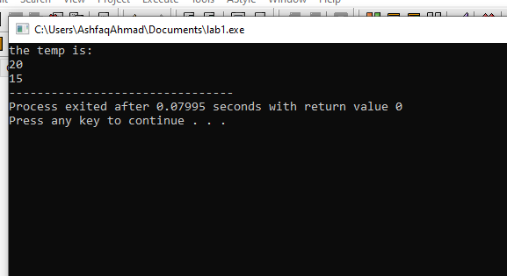

**Task no 2:**

Create a class called Point that has two data members: x‐ and y‐coordinates of the point. Provide a no‐ argument and a 2‐argument constructor. Provide separate get and set functions for the each of the data members i.e. getX, getY, setX, setY. The getter functions should return the corresponding values to the calling function. Provide a display method to display the point in (x, y) format. Make appropriate functions const.

**Source code:**

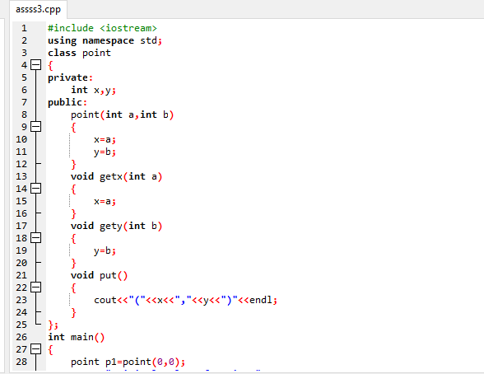

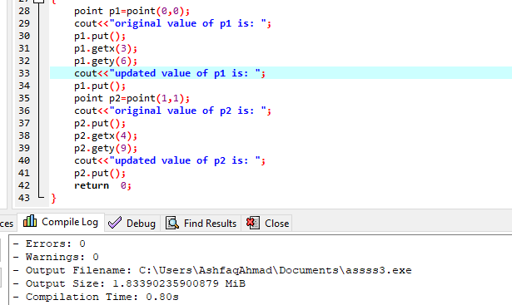

**Compilation:**

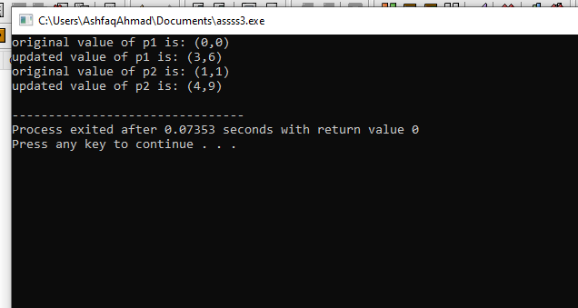

**Task no 3:**

Create a class called BankAccount that models a checking account at a bank. The program creates an account with an opening balance, displays the balance, makes a deposit and a withdrawal, and then displays the new balance. Note in withdrawal function, if balance is below Rs. 500 then display message showing insufficient balance otherwise allow withdrawal.

**Source code :**

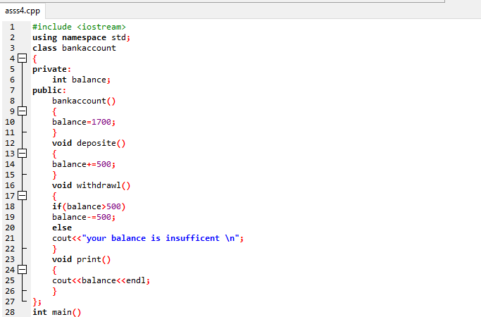

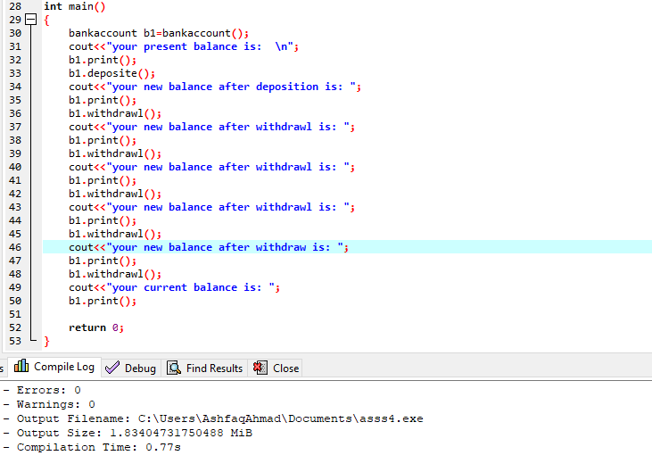

**Compilation:**

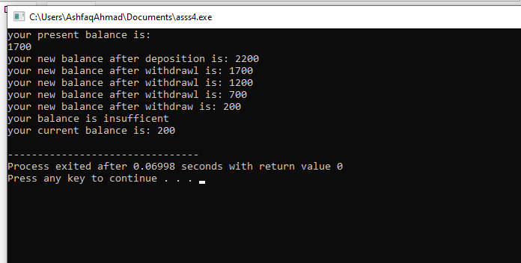

**THE END**